About the Syllabus

Welcome to the Alterity in Western Music Syllabus! This syllabus was compiled and edited by musicology graduate students in the Department of Music at the University of North Carolina at Chapel Hill. This project is the result of a seminar on the philosophical concept of alterity and its relationship to Western art music from 1885 to 1945. Based on the work of scholars such as Emmanuel Levinas, Homi Bhabha, and Simone de Beauvoir, the concept of alterity can help frame how we to understand the relation between Self and Other.

The syllabus is a pedagogical tool designed to provide access to the ideas discussed in the seminar beyond the walls of this university. By offering case studies from the Western musical tradition we intend to present practical examples on the different ways in which music might intersect with alterity.

The three units are interconnected in that they address similar questions. At the same time, however, each unit stands on its own. There is no preferred order in which to follow the syllabus. The units can serve either as a shorter module in a longer course, or as the core of a course that could be expanded with other examples—several of which are presented in the eZine. In alphabetical order, by composer, the units focus on the following topics:

1. Antonin Dvorak’s Symphony No. 9 From the New World. This unit offers engagement with the complicated web of Othering that surrounds the work of a Czech composer written in the United States evoking African American and Native American music.

2. The career of African American composer Florence B. Price (who wrote more than three hundred works) reveals how the concepts of race, gender, regionalism, and artistic networks can influence musical composition and reception. We focus on her Symphony No. 1 in E Minor and her art songs.

3. Camille Saint-Saëns’s musical suite The Carnival of the Animals opens a number of issues that arise when the Other is considered non-human.

While these three case studies allow us to explore how alterity has figured into Western music from 1885 to about 1945, there will inevitably be gaps that do not account for all forms of Otherness, time periods, or genres of music. Other resources on the site, such as the eZine and podcasts, engage with these and other case studies that take into account topics such as disability, sexuality, and social movements. We invite you to explore the concepts presented in the syllabus with other figures and musics.

As musicologists working within a discipline that historically has been compliant with colonial and racist practices, we listen to the voices of scholars who are calling for change in the way we practice scholarship and teaching. Recently, Phillip Ewell and Danielle Brown urged for changes in music studies to address inequalities of race and gender that affect methodologies and case studies. We are inspired by their contributions in the choices of our topics and in our pursuit of a public-facing project.

How to use the syllabus

The three units focus on case studies of composers and their repertoire in order to explore larger systemic concepts related to alterity. Each unit has two modules that approach these concepts from different angles by using musical examples. The modules include an introduction, listening section, primary and secondary sources, and self-guided assignments. We invite you to read through these units and modules in any order and at your own pace. We look forward to interrogating these concepts with you and to sparking conversations that can change the direction of music studies.

Team Syllabus

Introduction: Antonín Dvořák

Antonín Dvořák (1841-1904) was a composer from Bohemia, a region in the northern Habsburg and later Austro-Hungarian Empire in what is now the Czech Republic. Born to a large, rural, working-class Czech family, he received his early musical education in village schools and churches where he studied violin and viola. He later received formal musical education at the Prague Organ School, from which he graduated in 1859. For just over a decade Dvořák worked in the theater orchestra of the Provisional Theatre in Prague, where he played in productions of German, French, and Italian opera. After an early period of composition that closely imitated the German tradition of Beethoven and Wagner, Dvořák quickly developed a reputation as a Czech nationalist composer in the 1870s. He used Czech and other Eastern European folktales and folk tunes as inspiration for his operas, including The Cunning Peasant, and character pieces including the popular Moravian Duets and Slavonic Dances. He cemented his position in nineteenth century classical music and Czech national repertoire with later works including the sacred cantata Stabat mater (1877) and his operas The Devil and Kate (1899) and Rusalka (1901). With these, Dvořák gained an international celebrity, especially in England where he was invited to conduct his Stabat mater at the Royal Albert Hall, and was awarded an honorary doctorate from the University of Cambridge in 1891. But in the United States, he is largely known for his Symphony No. 9 in E Minor From the New World, curiously considered a catalyst for the development of uniquely American orchestral music.

Dvořák’s biography is distinct from contemporary German canonical figures such as Johannes Brahms, who are privileged in Western classical music history, and this distinction forms a double-edged sword where the composer’s reception is concerned. Dvořák is often situated as an implicitly inferior rustic/ethnic foil to the sophisticated Brahms and other Viennese elites. Though Brahms himself did not grow up very privileged, Dvořák seems provincial by comparison purely as a result of his position as a Czech Other outside of mainstream German bourgeoisie culture that dominated the Austro-Hungarian Empire. But Dvořák also enjoys a status as a sort of folk-hero in classical music history: an often-told story is that he apprenticed to a butcher before dedicating himself to music, though this has been proven to be a myth. This kind of mythology, which is reliant on romanticized or wholly imagined rustic origins, is important to understanding the lasting impression of Dvořák the man, and his music.

In the early 1890s he attracted the interest of wealthy American patron and impresario Jeanette Thurber who, at that point, was deeply involved in the creation of the fledgling National Conservatory in New York City. Thurber recruited Dvořák to serve a three-year term as its director between 1892 and 1895, with the express mission of producing a large-scale symphonic work representative of American musical style. The most prominent result of this tenure became his Ninth Symphony. Dvořák openly declared the work to be inspired by African American spirituals and Native American indigenous music, which he promoted as the true foundation for distinctly American musical idiom. These comments were then, as now, controversial, but the piece was well received by the American public and sparked a contest among American composers to produce nationalist music that was stylistically removed from the dominant German tradition of continental Europe. The popularity of Dvořák’s Ninth “New World” Symphony endures in the United States today, where the symphony’s supposedly American essence can be heard in concert halls, film soundtracks, and phone commercials.

Module 1: Dvořák as Other

Module Introduction
This module explores how Dvořák’s career was shaped by his Czech identity and how his national difference influenced his perspective as he composed and taught in the United States. In exploring Dvořák’s Symphony No. 9 From the New World, the composer’s position as Other in the U.S. emerges in relation to the American musical landscape at the end of the nineteenth century. This case study illuminates national difference, and how it is manifested in the symphonic tradition.

A Czech Background
Nineteenth-century Czech composers, like Dvořák and Bedřich Smetana, developed a musical style that relied on rural folk-idioms, however stereotypical, to distinguish their music from their Western European counterparts, however stereotypical. Dvořák knew, however, that using actual Czech folk melodies could be perceived as sounding simplistic and derivative by his audiences, and so he created a Czech-inspired musical idiom for his melodies. Because they were from a less recognized European background, these composers were compelled to “Other” themselves (or cast themselves as different) in the field of European classical music in order to have their music be valued as an original creation. This method of othering through foregrounding national musical characterisitcs may have inspired Dvořák’s approach to creating his version of an American musical language.

An American Sound
As mentioned in the Introduction, Dvořák came to America at the invitation of Jeanette Thurber with the goal of developing an American school of composition. Dvořák was an obvious choice for a composer in residence because Thurber admired how he had brought Czech music into the mainstream. She hoped he could do the same for American music.

Although American composers, such as William Henry Fry, Louis Moreau Gottschalk, George Whitfield Chadwick, and Amy Beach, were writing symphonic works at the time, too, today their music does not carry the same sustained popularity in the U.S. as Dvořák’s Symphony No. 9 From the New World. In his symphony, the composer wanted to include African American and Native American idioms to forge a genuine American music. In a manner similar to how he had written Czech folk-inspired themes, he composed melodies that encapsulated what he considered an authentic expression of American folk culture. This choice was controversial among some other American composers such as Chadwick and Beach who thought drawing from European idioms would be more authentic to American immigrant cultures and their lived experience. Even though Dvořák was loosely inspired by these American musical traditions, he was familiar only with a small amount of these rich musical traditions, mainly in the form of spirituals that his student Harry T. Burleigh sang for him. Therefore, his musical idioms draw on exotic stereotypes.

Dvořák’s position as a Czech composer in America gave him a different perspective on the cultural landscape. However, his limited time in the U.S. meant that his American-inspired thematic material was more rooted in stereotypical interpretation than in actual observation.

Primary Sources

Beach, Amy. “American Music,” Boston Herald, May 28, 1893.
Amy Beach questions Dvořák’s use of African American and Native American melodies to represent American music.

Dvořák, Antonín, “Music in America,” Harper’s New Monthly Magazine (February 1895), 429-434.

Secondary Sources

Beckerman, Michael, ed. Dvorak and His World. Princeton University Press. 1993.

Campo-Bowen, Christopher. “A Promising, Political Sound”: Epistemologies of Empire and Bedřich Smetana’s The Bartered Bride at the 1892 Vienna International Exhibition of Music and Theater,” The Musical Quarterly 102 (2019): 31-81.

Gelbart, Matthew. The Invention of 'Folk Music' and 'Art Music': Emerging Categories from Ossian to Wagner. New Perspectives in Music History and Criticism. Cambridge: Cambridge University Press. 2007.

Hepokoski, James. “Culture Clash. James Hepokoski Revisits Dvořák's New World Symphony.” The Musical Times 134 (1993): 685-88.

Shadle, Douglas W. Orchestrating the Nation: The Nineteenth-Century American Symphonic Enterprise. New York: Oxford University Press, 2016.

Sikand-Youngs, Nathaniel. “‘Another Spirit, Other Thoughts, Another Colouring’: Performances of Race in Antonín Dvořák's Symphony no. 9 from the New World.” HJEAS: Hungarian Journal of English and American Studies 23/ 2 (2017): xx-vv.

Investigations

Listening:
1) Dvořák Symphony no. 9 From the New World https://www.youtube.com/watch?v=VuaTY3zHO8Q
Listen for how the motive in the first movement is used throughout the other movements. Dvořák composed the African American and Native American inspired melodies based on the pentatonic scale which is noticeable particularly in the second and third movements.

Dvořák’s String Quartet No. 12 “American” https://www.youtube.com/watch?v=HrqgMrwG4i0
Similar musical idioms to the Symphony No. 9 are used in this string quartet. The melodies are African American-inspired and based on the pentatonic scale. In the third movement, there is a bird call sound supposedly transcribed from one Dvořák heard in America.

Dvořák’s Czech Suite in D Major https://www.youtube.com/watch?v=7-BfYeeoJ3U
Compare the Czech-style music in this suite to what you hear in the American-inspired pieces. This piece was written in 1879, more than a decade before his journey to the U.S.

2) Dvořák’s Symphony No. 9 From the New World has been used in many different settings, such as commercials, cartoons, and popular media. Pleas listen to the second movement used in this British commercial and to the drum corps Phantom Regiment’s performance of the fourth movement, and compare how these versions use the symphony and its associated meanings. How is Americanness represented in these examples and any other examples you may know of?

Critical Thinking:
Can you find other examples where this symphony is used, including mashups and re-mixes? What does this work signify? Americanness? Class?

In what ways does Dvořák’s experience writing a symphony compare to that of Florence Price whose work is discussed in another module?

Module 2: Dvořák, the Otherer

Introduction
Dvořák’s arrival in New York was surrounded by expectation both on the part of the composer and by the American music community. For Dvořák, stepping into the “New World” offered an opportunity to experience in reality what he (like many Europeans) had read about the continent in novels and newspapers. For the musical community in the United States, the composer’s arrival promised a connection between the European symphonic tradition and local compositional developments that were steeped in anxieties about whether there could be a music representing the American nation. Both shared concepts of these territories, cultures and populations, and both evinced the certainty that music would, and could, connect them.
These anxieties about a national music were expressed by the critic Henry Krebiehl who envisioned Dvořák as a mentor to, and an inspiration for, American composers – one whowould create a new symphonic sound. For Krebiehl, “aboriginal peculiarities of rhythm or melody,” or folk-songs, would be the ingredient with which to adapt Dvořák’s recipe to the continent. This formula of using the music of communities from the country-side turned out to be one of the main compositional strategies of Dvořák’s Symphony no.9 (From the New World), first performed in New York on December 15, 1893.
The subtitle of the symphony, From the New World, sets the music within a specific geographical location and suggests a perceptible relation to the source of these sounds. Dvořák’s efforts to use themes arising from his imagination of the territory mediated by books and his listening to the music while being there suggests issues of authenticity and appropriation, all the more as his concept of America was both mediated by books and garnered through selective listening after his arrival in New York. This module engages with Dvořák’s use of American communities and their musics, specifically racialized and indigenous populations, as one example of the representation of Otherness in a symphony.

“The Song of the Hiawatha”
In 1855, the epic poem “The Song of the Hiawatha,” was published in the United States and became an instant best-seller. Written by Henry Wadsworth Longfellow (1807—1882), a White poet born in Maine, who taught English at the Harvard College in Massachusetts, the book was quickly translated into several languages, including a Czech version in 1872. The poem is centered on Native American characters, in particular the Ojibwe warrior Hiawatha, and tells the story of his love for the Dakota woman, Minnehaha. Longfellow drew his inspiration for the narrative and form from two other works: Henry Rowe Schoolcraft’s Personal Memories of a Residence of Thirty Years with the Indian Tribes of the American Frontiers: With Brief Notices of Passing Events, Facts, and Opinions, A. D. 1812 to A. D. 1842, and Elias Lönrrot’s Finnish epic Kalevala (1835/1849). Despite references to oral histories of the Native American groups incorporated to the narrative (that include some uncredited knowledge of Native American sources from Schoolcraft), some readers of the poem criticize its free use of the stories by Longfellow. Nevertheless, the commercial success of the book and its circulation across the world created images not only of Native Americans but also about America that shaped the way in which both Americans and readers elsewhere in the world imagined the continent.
One of the readers abroad was Czech composer Antonín Dvořák. As the musicologist Michael Beckerman states, Dvořák “fell under the spell of the Hiawatha,” even before his travel to the “New World.” Jeannette Thurber, the patron of Dvořák’s enterprise in America, gave to the composer an English copy of the book upon his arrival to the country. The press speculated about a possible opera project based on the story. As Dvořák mentions in an interview on the day of the first performance of his Symphony No. 9 From the New World, the poem is echoed in the second and third movements of the work (see Primary Sources). The press expanded on Dvořák’s comments including not only references to the poem but also to Native American sounds. Although Dvořák had interest and the chance to meet indigenous populations in the United States, there is no evidence that he engaged with their sounds in his compositions.

Listening to Spirituals
During his period teaching at the National Conservatory of Music of America, Dvořák was able to listen to musical traditions different from his homeland and incorporate them in his own compositions. Initiated by Jeanette Thurber, the Conservatory supported a project of promoting African American musical practices by including it under a proposal of a national music. The institutions gave access to musical training for exceptional students of color and offered a way to include them in this national project (see Primary Sources). One such student, Harry T. Burleigh, remembers singing songs of African American tradition for Dvořák. Burleigh also states that Dvořák “filled himself with the spirit of the old Spirituals,” even before composing his own themes, including a direct reference to Swing Low, Sweet Chariot in the first movement of the Symphony. Different from the symphonies of African American composers such as William Grant Still’s Symphony no. 1 “Afro-American” and Florence Price’s “Juba Dance” from her Symphony No. 1 that directly refers in their compositions to a racial inspiration, Dvořák’s Symphony No. 9 acknowledges the territory from an explicitly foreign perspective (From the New World) that does not explicitly recognize race.

Primary Sources
Excerpt of New York Herald, December 16, 1893.
Horowitz, Joseph. “Dvořák and Boston.” American Music 19/1 (2001): 3-17.

Whoever it was, he seemed modestly to wish to remain at the back of the box on the second tier. At last a broad shouldered individual of medium height, and as straight as one of the pines in the forests of which his music whispered so eloquently, is descried by the eager watchers. A murmur sweeps through the hall. “Dvořák! Dvořák!” is the word that passes from mouth to mouth.... With hands trembling with emotion Dr. Dvořák waves an acknowledgement of his indebtedness to Anton Seidl, to the orchestra, to the audience, and then disappears into the background while the remainder of the work goes on.... At its close the com- poser was loudly called for. Again and again he bowed his acknowledgements, and again and again the applause burst forth. Even after he had left his box and was walking about in the corridor the applause continued. And finally he returned to the gallery railing, and then what a reception he received! The musicians, led by Mr. Seidl, applauded until the place rang again.

Excerpt of “Real Value of Negro Melodies,” New York Herald, May 21, 1893.
Music in the USA, edited by Judith Tick. 311—312.
The National Conservatory of Music of America, 126 and 128 East Seventeenth Street, New York, May 16, 1893
The National Conservatory of Music of America proposes to enlarge its sphere of usefulness by adding to its departments a branch for the instruction in music of colored pupils of talent, largely with the view of forming colored professors of merit. The aptitude of the colored race for music, vocal and instrumental, has long been recognized, but no definite steps have hitherto been taken to develop it, and it is believed that the decision of the Conservatory to move in this new direction will meet with general approval and be productive of prompt and encouraging results. Several of the trustees have shown special interest in the matter. Prominent among these is Mrs. Colus P. Huntington. Tuition will be furnished to students of exceptional talent free of charge. Two young but efficient colored pupils have already been encouraged as teachers and others will be secured as circumstances may require. Application for admission to the Conservatory classes is invited, and the assignment of pupils will be made to such instructors as may be deemed judicious. Dr. Antonin Dvorak, director of the Conservatory, expresses great pleasure at the decision of the trustees, and will assist its fruition by sympathetic and active cooperation. May I ask you to place these facts before your readers and in favoring a worthy cause once again oblige yours, very truly.
JEANNETTE M. THURBER, President

Secondary Sources
Beckerman, Michael. “Dvořák's “New World” Largo and “The Song of Hiawatha”.” 19th-Century Music 16/1 (1992): 35-48.

Burleigh, Harry T. “The Negro and His Song,” in Music on the Air, ed. Hazel Gertrude Kinscella. New York: Viking, 1934: 186–89.

Horowitz, Joseph. “Dvořák and Boston.” American Music 19/1 (2001): 3-17.
Tick, Judith and Paul Beaudoin (ed.) Music in the USA: A Documentary Companion. New York: Oxford University Press, 2008.

Nurmi, Tom. “Writing Ojibwe: Politics and Poetics in Longfellow’s Hiawatha.” The Journal of American Culture 35/3 (2012): 244-256.

Shadle, Douglas. Antonín Dvorak’s New World Symphony. New York: Oxford University Press, 2021 (forthcoming).
Investigations

1) In 1893, Chicago hosted the Columbian World’s Fair which celebrated the four-hundredth anniversary of the “discovery” of the Americas by Christopher Columbus. The 1893 World’s Fair gathered millions of people interested in seeing the pavilions that included representation of cultures from all around the world, from indigenous populations that lived not far from the area to distant “exotic” groups of faraway colonies. One of the visitors of the exhibition was Antonin Dvorak, who conducted a concert in tribute to the Bohemian Day on August 12, 1893.
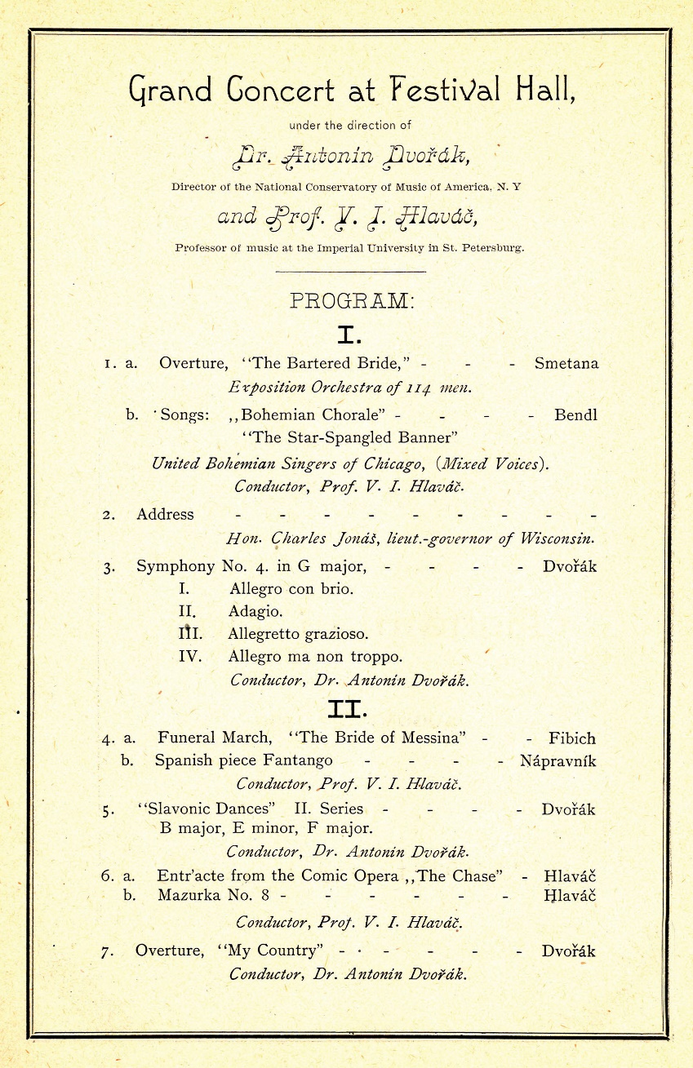
Source: Chicago Symphony Orchestra Archives. <https://csoarchives.files.wordpress.com/2016/07/dvorak-1893-b.jpg>

Several of the artifacts and objects that Dvorak and other visitors saw at that exhibition gave origin to the collection of Chicago’s Field Museum, which lists as its mission to fuel “a journey of discovery across time to enable solutions for a brighter future rich in nature and culture.”
Explore the collection of the museum from their blog and catalogue (provided in the links bellow) and answer the following questions in connection to the texts on Dvorak.

Field Museum blog <https://www.fieldmuseum.org/blog/travel-back-worlds-fair-our-collection>
Field Museum’s resources on the 1893 World’s Columbian Exposition <https://libguides.fieldmuseum.org/1893>

- By seeing the collection of objects from the exhibition (including fossils, animals, and art from different cultures) how would you describe the communities represented in the exhibition?
- By listening to Dvorak’s Symphony no. 9 (From the New World) that takes inspiration from North American communities, how is Dvorak’s representation of the sounds of these groups different from the museum?
- In the twentieth-first century, what are the ethics involved in exhibiting these works and playing this symphony?

2) As you have read in the text of this module, since before its completion, critics announced Dvorak’s inspiration from Native American music in the composition of his symphony. The musicologist Michael Beckerman writes about some different ways in which the second movement of the work, the Largo, is possibly connected to the chapter of Longfellow’s “The Song of the Hiawatha,” named “Hiawatha’s Wooing.” Read this chapter of the poem (available in the link bellow) and complete the following instructions.

Henry Wadsworth Longfellow, “Hiawatha’s Wooing” from “The Song of the Hiawatha”. <https://www.hwlongfellow.org/poems_poem.php?pid=284>)

- Write down the names of the ethnic tribes represented in the poem (tip: the names are referred to their relationship with their lands).
- Using the following digital map < https://native-land.ca/> find the territories that belonged to the tribes named in the poem. Write down the names of the modern states settled in these territories.
- Do your own research on these Native American populations and learn more about their history and culture (you can find YouTube videos that provide good introduction that include examples of their uses of sound). What aspects of these cultures are used by Longfellow and Dvorak? What aspects of their culture were ignored or misrepresented in the poem and the symphony?

Introduction: Florence B. Price

When people think of Western art-music composers, one of the first images that often comes to mind is that of the genius. The narrative of music being created by gifted and special individuals whose works seem to transcend life and history is usually associated with a very specific demographical profile: male, White, and European. Much of the music history written in the nineteenth and twentieth centuries tended to center this imagined character as its protagonist, creating a hierarchy not only of the compositions that they produced but also of their standing as individuals. The reproduction of this hierarchy across histories and pedagogies of music contributed to make less visible and less audible the contribution of musicians who diverged from this norm. Indeed, individuals who differed from this profile were commonly relegated to a supporting role in the overall narrative. It is not a coincidence that many of the individuals marginalized in this kind of historiography are marked as Others based on their race and gender. For example, music-history textbooks still teach us that, in the past, women would sing and play the piano, thus bringing to life the compositions of the genius composers, and that the music of exotic and foreign communities (also known as non-Western) could be used as a source of inspiration for the “great men” in question. The problem with this narrative is that it produces and reiterates the erasure of other musical stories that—by not being written—are misrepresented and often forgotten.

One of these ignored stories that has been brought to life recently is that of the composer Florence B. Price. Born in 1887 in Little Rock, Arkansas, Price achieved great success as an African American woman composer in the United States in the first half of the twentieth century. The success, however, is usually framed through her intersectional identity as a woman in a patriarchal society and as a Black musician in an age of segregation and racism. Although Price grew up amidst the Black elite of Arkansas, attended prestigious educational institutions such as the New England Conservatory, and had her work presented by some of the most important musical performers of her time, including the premiere of her First Symphony in 1933 by the Chicago Symphony Orchestra, the narratives speaking to her success are frequently limited to tokenizing her achievements.

By focusing this unit on some of Price’s compositions, her career, and the web of stories woven by putting her at center stage, we invite students to think about music, alterity, and history. Rather than relativizing her accomplishments as a secondary character in music history, we focus the attention on her works and contribution in the United States during the first half of the twentieth century. This perspective allows for a broader reflection on the role of alterity in providing meaning to music across time and on the potential histories enabled by a narrative not centered on the usual White male protagonist. The challenge of proposing a reading of history against the grain is not to reproduce the same logic that creates hierarchies and that identifies and labels Others who remain excluded. Rather than rewriting a linear music history centered on Florence B. Price, however, in the two modules that follow this introduction, , we think of her from the multiple perspectives that emerge from the different positions she occupied in the artistic networks of her period. Instead of presenting a singular life that can be objectified, we pursue the potentially diverse narratives that emerge by considering a multiplicity of ways to tell stories about musicians and their works.

Module 1: Symphony No. 1 in E Minor

Module Introduction
By 1931, Florence B. Price lived in Chicago, divorced and independent, and composing seriously for the first time since college. Although she had written numerous children’s and practice pieces for her piano students in Arkansas, Price only turned to composing major orchestral works relatively late in life, when she was in her mid-forties. Her Symphony No. 1 in E Minor became her first big success. She wrote the majority of her symphony in 1931, finding humor and serendipity in an accident when she wrote to a friend, “I found it possible to snatch a few precious days in the month of January in which to write undisturbed. But, oh dear me, when shall I ever be so fortunate again as to break a foot.” The resulting piece was well received nationwide, granting Price a degree of legitimacy that encouraged her to continue writing major orchestral works. Three more symphonies, three concertos, assorted smaller orchestral works, and more than one hundred songs would follow the moment when Price found a powerful public stage for her pieces at the Chicago World’s Fair of 1933.

The Symphony
Price’s Symphony No. 1 in E Minor consists of four movements. The first, Allegro non troppo, is in traditional sonata form and that lasts nearly fifteen minutes. This movement deliberately hearkens to Antonín Dvořák’s Symphony No.9 “From the New World”—a self-conscious nod to newly solidified conventions in the American orchestral sound and a claim on ten part of Price to being an integral part of this new, national symphonic tradition. The second movement, Largo, is a ten-part brass choir playing a newly composed hymn, accompanied by drumming. The third movement is notable for its expressive name, “Juba Dance,” which invokes an African-derived folk dance that was popular among slaves in the antebellum South, and for its brevity—the movement does not last four minutes. Price plays here with the expectation of a dance as the third movement of a classical symphony (which in European symphonies is often a minuet) and explores an African American musical style anchored in the South of the United States. It concise format allows it to pass for a work of popular music. The last movement, Finale, is a fast movement of about five minutes in the form of a modified rondo. The use of the pentatonic scale, vital to African American musical idioms such as jazz and blues, is prominent throughout the work.

Initial Reception of the Symphony
In 1932, Price entered her symphony into the national Rodman Wanamaker composition competition and won the prize for the symphonic category—a great honor that brought her national attention. This award attracted the interest of Frederick Stock, conductor of the Chicago Symphony Orchestra. Stock and his orchestra premiered the piece on June 15, 1933, at the Chicago World’s Fair, as part of a concert dedicated to “The Negro in Music.” This was the first performance of a symphony written by an African American woman ever to be performed by a major symphony orchestra. Both Black newspapers—such as the Chicago Defender—and the White press, including the Chicago Daily News, sung the symphony’s praises. Her success spurred Price to greater ambitions. She sent scores and letters to conductors of prestigious orchestras, most notably Serge Koussevitzky of the Boston Symphony Orchestra, trying to get her work performed, but had little luck outside Chicago.

The 1933 Chicago World’s Fair
Given the motto, “A Century of Progress,” the World's Fair: Columbian Exposition in Chicago took place from May to November 1933 and, again, from May to October 1934. It marked the 150-year anniversary of the founding of Chicago. Plans for the massive Exposition began before the stock market crash of 1929 that catalyzed the Great Depression, but despite the myriad hardships many Americans faced during this time, the Fair proceeded more or less as planned. The boisterously successful Fair became a symbol of hope for American progress and recovery in the midst of economic turmoil and national crisis. The African American community of Chicago fought hard to be involved with the Fair, seeing it as an opportunity to promote their artistic and historical accomplishments. Despite discriminatory practices at the 1933 Exposition that led some in Chicago’s Black community to boycott the Fair, the NAACP successfully lobbied for state legislation to bar racial discrimination from the 1934 Fair.

Nationalist and African American Vernacular Influences
Price’s compositional style is distinctive, and she took inspiration from a variety of elements. Her training at the New England Conservatory by George Chadwick familiarized her with the compositional style of Antonín Dvořák. This Czech composer had set the standard for American-style symphonic texture by taking inspiration from African American spirituals and Native American folk song, most famously in his Symphony No. 9 “From the New World.” Price’s teacher, Chadwick, was a member of the “Boston Six” cohort of American nationalist composers who continued to develop what became the quintessential American orchestral sound of the early twentieth century. He encouraged Price to explore the use of spirituals and other African American musical idioms in her compositions. Price seemed particularly fond of the Juba dance, which appeared not only in her first but also her third symphonies.

Performance History
After its premier in 1933, Price’s Symphony No. 1 was performed infrequently. What might have contributed to this neglect is the fact that the Symphony was not published until 2008; all previous performances relied on manuscripts and photostats. Price’s Symphony has recently enjoyed new popularity among American orchestras. Whereas the symphony was known to have only two performances in 2018, in 2019 the Symphony (or excerpts of the Symphony) were performed seventy-one times by orchestras across the country, including the National Symphony Orchestra. In 2020, sixty-two performances were planned, though many were canceled due to the COVID-19 pandemic.

Primary Sources

Brascher, Nahum Daniel. “Roland Hayes.” Chicago Defender, June 24, 1933.

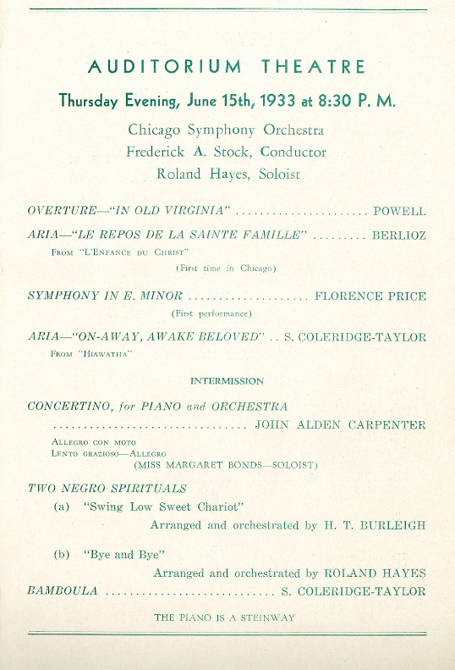
CSO Sounds and Stories. “125 Moments: 072 Price’s Symphony in E Minor.” Last modified May 5, 2016. Accessed October 4, 2020.
https://csosoundsandstories.org/125-moments-072-prices-symphony-in-e-minor/.

George, Maude Roberts. “Wanamaker Awards Given in Music.” Chicago Defender, October 1, 1932.

Price, Florence Beatrice Smith, letter to Serge Koussevitzky, July 5, 1943. Library of
Congress, Music Division.

Price, Florence. Symphonies Nos. 1 and 3. Edited by Rae Linda Brown and Wayne Shirley. Middleton, WI: Published for the American Musicological Society by A-R Editions, 2008.

Stinson, Eugene. Chicago Daily News, June 16, 1933.

Secondary Sources

Brown, Rae Linda. “Florence B. Price’s ‘Negro Symphony.’” In Temples for Tomorrow: Looking Back at the Harlem Renaissance, edited by Geneviève Fabre and Michel Feith, 84-98. Bloomington: Indiana University Press, 2001.

Price, Florence. Symphonies Nos. 1 and 4. Conducted by John Jeter. Recorded with the Fort Smith Symphony, May 13-14, 2018. Naxos 8.559827, 2019. CD.

Reed, Christopher Robert. “The Rise of Black Chicago’s Culturati: Intellectuals, Authors, Artists, and Patrons, 1893-1930.” In Roots of the Black Chicago Renaissance: New Negro Writers, Artists, and Intellectuals, 1893-1930, edited by Richard A. Courage and Christopher Robert Reed, 22-42. Urbana: University of Illinois Press, 2020.

Rydell, Robert W. “Century of Progress Exposition." The Electronic Encyclopedia of Chicago. Chicago Historical Society, 2005. Accessed September 26, 2020. http://www.encyclopedia.chicagohistory.org/pages/225.html.

Wise Music Classical. “Florence Price Symphony No. 1 in E Minor (1932).” Accessed September 28, 2020. https://www.wisemusicclassical.com/work/58893/Symphony-No- 1-in-E-minor--Florence-Price/.

Investigations

Listening:
In the period from the late nineteenth century through World War II, composers from across the country were involved in a sort of artistic arms race for the “Great American Symphony,” a contest to develop a uniquely American contribution to this traditionally European genre. Florence Price’s Symphony No. 1 in E Minor made her a contender in this fight. Compare this Symphony other landmarks in the genre such as Amy Beach’s Gaelic Symphony, William Grant Still’s Afro-American Symphony, Roy Harris’s Symphony No. 4, or Aaron Copland’s Symphony No. 3. What strategies do the composers use to represent nation (Americanness) in these works?

Research:
Consult the 1933 World’s Fair concert program, and conduct some research on the performers and composers who were featured alongside Price at that World Fair concert in 1933. You will find, for example, that one of the other composers on the program, John Powell, was a staunch White supremacist who lobbied for Jim Crow legislation. What does the concert program say about the representation of music by people of color during this period?

Critical Thinking:
1. This symphony was the first symphony by an African American woman performed by a major U.S. symphony orchestra, and it was well received at its premiere. Price was also a fairly prolific composer who traveled in the same circles as the Boston Six nationalists, and some of the most important figures of the Chicago Black Renaissance, as you will see in Module 2 below. Yet despite Price’s accomplishments and artistic pedigree, her symphony was little performed prior to 2019 and is rarely taught in music schools. What do you consider are the barriers to this piece’s, and Price’s, inclusion in the Western classical-music canon?

2. What is a World’s Fair and what is its purpose? How does a concert dedicated to “The Negro in Music” fit into that purpose?
Module 2: Art Songs

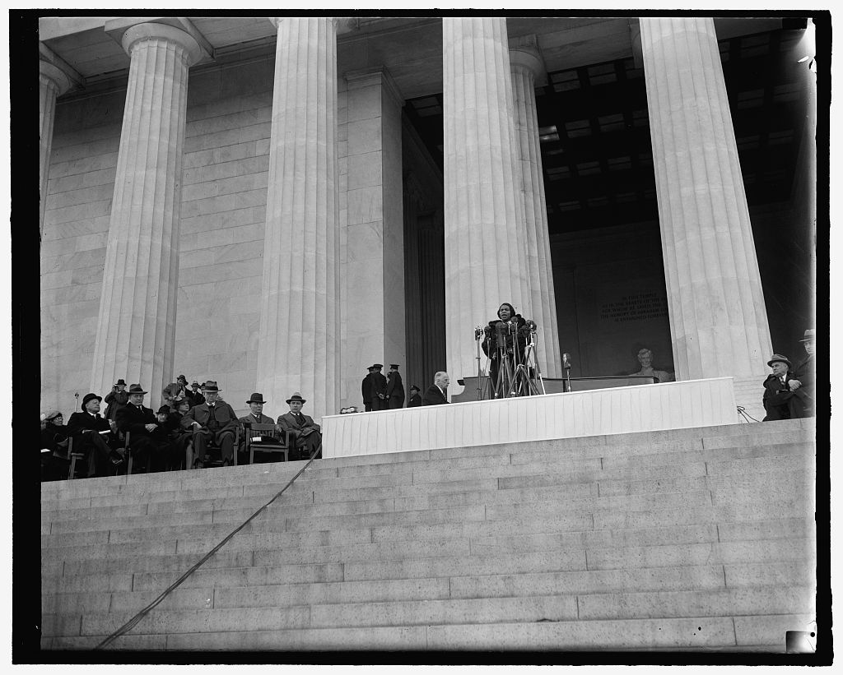
Module Introduction
In this module, we focus on Price’s songs in the contexts of prevailing power structures and networks of creative communities in order to explore how her music was created and spread. While Price used many musical forms, her songs are among the most collaborative ones. They demonstrate how different facets of her identity placed her in social structures which affected her career. Price worked with numerous distinguished artists like singer Marian Anderson, choreographer Katherine Dunham, and poet Langston Hughes.

National Reach
Surrounded by microphone stands in front of a crowd of 75,000, Marian Anderson sang on the steps of the Lincoln Memorial on Easter Sunday 1939. The last song on the program was Florence Price’s arrangement of the spiritual “My Soul’s Been Anchored in the Lord.” Anderson performed at the Lincoln Memorial because she was blocked by the Daughters of the American Revolution from a scheduled performance at Constitution Hall based on the fact that she was Black. In closing the program with a song written by a Black female composer, Anderson made a statement about racial equality and presented Price’s music to a larger audience. Anderson’s performance would make way for further progress against segregation and discrimination in the years following. For further context, it would be almost a quarter of a century before Martin Luther King would stand on the same steps of the Lincoln Memorial to deliver his “I Have a Dream” speech.

Spirituals and Black Performance
Price arranged spirituals for singing and incorporated spiritual melodies into some of her instrumental music. Spirituals are African American vernacular songs with texts based in Christian religious thought. Listeners at the time perceived spirituals as authentic musical expression of the antebellum South and a true form of American folk song. Like Anderson, other African American singers in the twentieth century embraced the popularity of spirituals, incorporating them into their concert performances along with Western classical repertoire.

Local Influence: The Chicago Black Renaissance
Like the African American arts communities in New York forming the better-known Harlem Renaissance, of the ones in Chicago flourished after World War I when the city saw an influx of Black residents during the main years of the Great Migration (1916-1918), and a vibrant arts and intelligentsia community rose even amidst the struggles of the Great Depression. The city became a hotspot of culture during the “Jazz Age of the 1920s.” It became the birthplace of a rich artistic community that began in the 1910s but saw its greatest period of recognition in the late 1920s and 1930s, spearheaded by the literary works of Richard Wright. 1927 was an especially important year, which saw the Negro in Art Week exhibition held at the Chicago Art Institute, celebrating Chicago’s rich African American cultural life. Notable figures associated with the Chicago Black Renaissance spanned the arts, including writers (Arna Bontemps, Margaret Walker, and Gwendolyn Brooks), visual artists (William Edouard Scott, Charles White, Archibald John Motley, Jr., and Eldzier Cortor), gospel and jazz figures (Thomas A. Dorsey, Mahalia Jackson, and Louis Armstrong), and choreographer Katherine Dunham. In fact, Price wrote the music for Dunham’s concert dance, Fantasie Nègre, in 1936. Price traveled in the same circles as many influential Chicago writers and performing artists who encouraged and influenced her work.

Price's Networks
In Chicago, Price was connected to additional Black social networks that supported her work like the R. Nathaniel Dett Club and the National Association of Negro Musicians of which she was one of the most visible members. Her work was reviewed by the African American newspapers, including one of the most influential ones, the Chicago Defender. Price would often attend Black salons and social events held at the home of Estella Bonds, mother to composer and pianist, Margaret Bonds, or at the Parkway Community house. She lived for a time in the Bonds’ home and took an active role in mentoring the young Margaret Bonds and her compositional career. Price became acquainted with the already famous Langston Hughes at one of the many Black artistic events in Chicago. In setting some of his poems to music, Price used the work of the well-known poet to play with ideas of double consciousness in the African American experience. Double consciousness is a term coined by W.E.B. Dubois to show the tension of reconciling an African heritage through the frame of a White colonial racist society. In the selection of songs below, “Hold Fast to Dreams” and “Song to the Dark Virgin” are based on Langston Hughes’ poems.

Price’s identity as a woman also influenced her professional connections. As an African American with lighter skin, Price was afforded the opportunity to be involved with White women’s social networks to which darker skinned peers may not have been permitted. The Musicians Club of Women and the Chicago Club of Women Organists were organizations to bolster support for female musicians because they were being excluded by men. The organizations held social events and salons that led to Price’s work being heard by more members of the musical scene.

Legacy
Price’s reputation as a composer spread nationally and internationally until her death in 1953. In 2009, a couple in Illinois found unpublished manuscripts in her old house, and in 2019, her publisher Schirmer found additional manuscripts presumed lost. Writers have credited this as a “rediscovery” of Price and her music. The narrative discredits the work of historians such as Rae Linda Brown, however, who consistently researched Price and her music. Certainly, Price’s music has not traditionally been included in the classical-music canon, but her work never really disappeared. This module offers a way to view Price’s background with regard to the social structures that both limited, and helped to spread, her work. Many of Price’s songs have been published and they cover a range of topics for a variety of voice types. Still more songs may see the day, even though they remain so far in manuscript form.

Listening: Selected Songs

“My Soul’s Been Anchored in the Lord” (1937), performed by Marian Anderson and Franz Rupp.
https://www.youtube.com/watch?v=z02yZIoPPlI
Listen for how Anderson enunciates the text. In the score, the last note has an option to go higher in pitch which is presumed to have been written to showcase Anderson’s vocal range.

“Hold Fast to Dreams” (1945), performed by Louise Toppin and Lydia Qiu.
https://www.youtube.com/watch?v=qFoEWPGsrvk
This song uses the text from a Langston Hughes poem “Dreams.” Listen for how the text and music accentuate one another. The piano at the end shifts through different harmonic registers leading up to a dramatic flourish which performers have described as characteristic for Price.

“Song to the Dark Virgin” (1941), performed by Darryl Taylor and Maria Corley.
https://www.youtube.com/watch?v=18-JLvwT0-4
Based on another Langston Hughes poem, this song presents some moments of text painting in which words like jewel and dark are accompanied by a change in the harmony to emphasize their meaning.

Primary Sources
Price, Florence, and Richard Earl Heard. 44 Art Songs and Spirituals. Fayetteville, AR: ClarNan Editions, 2015.

"Civic Group Entertains Two Noted Women Composers." The Chicago Defender (National Edition), August 24, 1946.

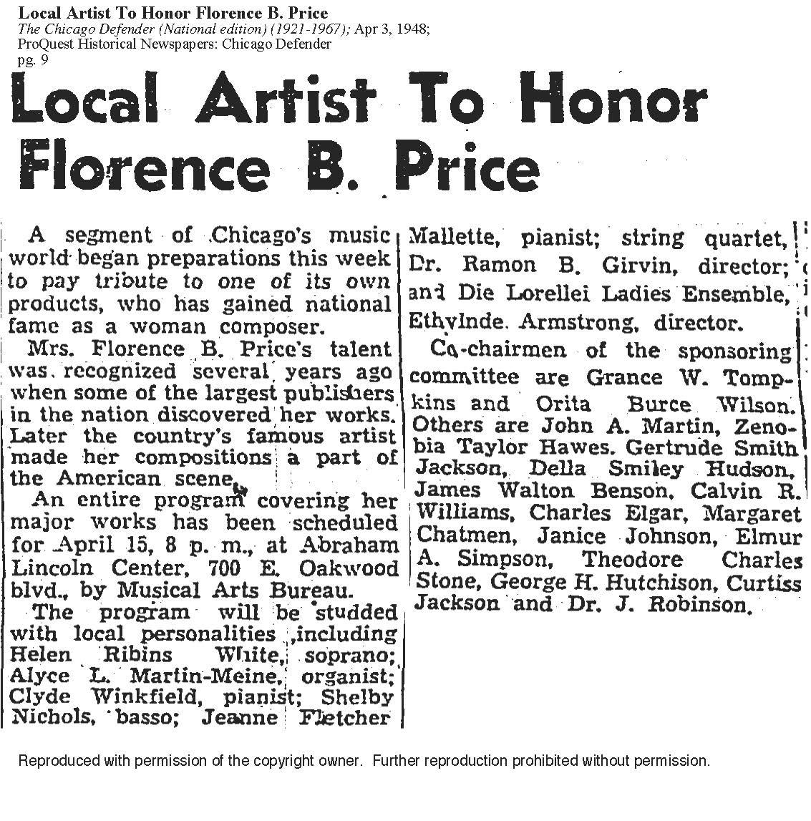
"Local Artist to Honor Florence B. Price." The Chicago Defender (National Edition), April 3, 1948.

"Musical Works by Members on Club Program." Chicago Daily Tribune (1923-1963), February 6, 1949.

Secondary Sources
Brown, Rae Linda. The Heart of a Woman: The Life and Music of Florence B. Price. Champaign-Urbana: University of Illinois Press, 2020.

Jones, Alisha Lola. NPR.org. “Lift Every Voice: Marian Anderson, Florence B. Price and The Sound Of Black Sisterhood.” Published August 30, 2019. https://www.npr.org/2019/08/30/748757267/lift-every-voice-marian-anderson-florence-b-price-and-the-sound-of-black-sisterh

Peters, Penelope. "Deep Rivers: Selected Songs of Florence Price and Margaret Bonds." Canadian University Music Review 16, no. 1 (1995): 74-95. https://www.erudit.org/en/journals/cumr/1900-v1-n1-cumr0466/1014417ar.pdf

Ross, Alex. “The Rediscovery of Florence Price.” The New Yorker. Published January 29, 2018. https://www.newyorker.com/magazine/2018/02/05/the-rediscovery-of-florence-price.

Thurman, Kira. "Performing Lieder, Hearing Race: Debating Blackness, Whiteness, and German Identity in Interwar Central Europe." Journal of the American Musicological Society 72 no. 3 (2019): 825—865.

Walwyn, Karen. Florence Price. http://www.florenceprice.org/

Investigations
1) Learn more about some of the major figures in different arts disciplines of the Chicago Renaissance. What might be some of the reasons why the Harlem Renaissance is significantly better known than the Chicago Renaissance? In your research, compare Gwendolyn Brooks’ poem “truth” to Langston Hughes “Dreams.” Hughes said about the Chicago poet “the people and poems in Gwendolyn Brooks’ book are alive, reaching, and very much of today.” You can read more about her and read selected poems on the Poetry Foundation Website.

2) How does Price deploy such musical elements as melody, texture, range, rhythm, and dynamics (among others) to interpret the text of Hughes’ poems in “Hold Fast to Dreams” and “Song to the Dark Virgin”? How might the concept of double consciousness be applied to analyze these songs?

3) Using Price’s career as an example, explore how other composers’ artistic and social lives influenced their work. Consider the composers in the other modules, Dvořak and Saint-Saëns, or maybe more contemporary examples such as Courtney Bryan or Sarah Kirkland Snider. How were other composers affected by their social networks and by societal power structures? In what ways might this be reflected in their music, or might they deliberately resist such an entanglement of biography and creation?

Introduction: Camille Saint-Saëns and the Carnival of the Animals

Camille Saint-Saëns (1835-1921) considered himself a friend to animals and today one of his best-known compositions is the orchestral suite, The Carnival of the Animals, which he wrote to entertain his human friends at parties. The different animals featured in the movements were parodies of figures in the musical community like critics and conductors. The piece contains fourteen movements that each depict different animals including tortoises, kangaroos, and surprisingly, pianists. Filled with musical jokes, instruments mimic animal noises or imitate themes from other popular musical pieces. Fearing the piece was too silly, Saint-Saëns forbade this composition to be published until after his death. “The Swan” was the only movement published during his lifetime, in 1887.

He described his choice to publish the piece posthumously in a letter to his friend Charles Lebouc: “My will forbids any publication of my unpublished works, except for The Carnival of the Animals. Long live the animals! Down with the humans! except us two, of course" (23 July 1911). This letter reveals that while Saint-Saens did not want to be known for this work, he thought highly of the animals about whom he was composing, so this became the only exception to his publishing ban after his death.

Saint-Saëns’s musical style was less modern than other counterparts working in France during the nineteenth century. Although he lived into the twentieth century, his work is considered to fall within the Romantic era except for some neoclassicism toward the end of his career. Apart from the Carnival of the Animals, other notable compositions included the opera Samson and Delilah and his concerto works; the First Cello Concerto, the Second Piano Concerto, and the Third Violin Concerto.

Saint-Saëns himself did not fit into the identity categories we traditionally think of as Other. He was a European, White, able-bodied man with considerable privilege. In this unit, rather than focusing on Saint-Saëns himself, we turn attention to what his work, the Carnival of the Animals, reveals about alterity.

In thinking about what makes an animal, some questions emerge. How do animals sound and move in music? Is it possible for instrumental music to represent the “voices” of animals? How is humanity different than animality? What makes a human?

Module 1: Animals as Others and Others as Animals

Introduction
As explained in the Introduction to this unit, Saint-Saëns mocked his critics with Carnival of the Animals, portraying them variously as skittish chickens, lumbering tortoises, and braying asses. Criticizing people by comparing them to animals is both an old and a current cultural practice—see, for example, the sloths that work at the DMV in Disney’s Zootopia (2016)—but it has not always just been music critics or irritatingly slow administrators who have been the objects of this derision. Historically, people of minority racial, gender, or socio-cultural groups have often been derogatorily compared to animals, arising from the fact that at one time they were not considered fully human. Societally ingrained and legally sanctioned notions that some people are inferior made animal comparisons an easy reach. Another group of people who are often associated with animals are children, and this is perhaps why the Carnival of the Animals has come to be thought of as a children’s piece, though it was not composed for this purpose. When animals are used to represent racial minorities, women, and children, it situates them as Others different from an ideal of humanity that is grown, able-bodied, White, and male. Everyone else is treated as an improperly—or not yet fully—formed person.

Animals in Children’s Music
Cultural products aimed at children convey societal expectations for that child, ones that they must grow into. Dolls impart a physical ideal, stories have morals, and children’s music suggests appropriate cultural values a child should come to appreciate. These values might include the innocuous themes of friendship and board-approved expressions of individuality embodied by Disney Channel pop stars, or they might be the high-culture ideals of classical music through which children will supposedly become more sophisticated and intelligent adults. As Schumann scholar Roe-Min Kok points out, children’s music, marketed to parents who most wish to groom their children according to these ideals, can be very lucrative. But to be effective children’s pieces, they must appeal to children to some extent, and animals are often used to garner this appeal. Many of the most famous classical pieces for children include animal themes: Sergey Prokofiev’s Peter and the Wolf (1936), Maurice Ravel’s Mother Goose (1910), or “Jimbo’s Lullaby” (based on an elephant kept in Paris) from Claude Debussy’s Children’s Corner (1908). Pieces such as Peter and the Wolf, or the collection Animal Folk Songs for Children (1950) arranged by Ruth Crawford Seeger, are examples of music performing “social work” on children—in Prokofiev’s case promoting Bolshevik ideals of overthrowing old ways of thinking and overcoming nature, in Crawford Seeger’s of kindling a sense of unified national heritage.

The Unknowable Other: Woman
Foundational feminist philosopher Simone de Beauvoir asserted that men’s failure to recognize autonomous female personhood results in making women the default Other in society. In her book, The Second Sex, she further reveals a common desire among men to think of a woman as a domestic animal or piece of flesh for consumption. Her revelation helps to explain a curious convention of language: men (and sometimes women) often compare sexually enticing women to pussycats, vixens, or bunnies, elegant women to swans, sweet women to lambs, and those who are objects of contempt to cows, heifers, pigs, snakes, old bats, and bitches. The children’s folk song “I Bought Me a Cat,” which was arranged by Aaron Copland in Old American Songs (1950-52), tells of a farmer who buys a series of animals, feeds them, listens to the sounds they make, and is pleased by them. In the best-known version, his final acquisition is a wife whom he feeds like the animals of previous verses, and whose voice joins the parade of farm animals that recite their cries to end the song.

Animal Allegories
In Western media, talking or anthropomorphic animals are often used to euphemize the sensitive issues of race for children. Consider a movie like Warner Brothers’ Cats Don’t Dance (1997), in which humans oppress upright-walking, talking, and dancing animal actors to keep them from being cast in meaningful roles in movies and restrain them to only playing animal parts. Somehow, Warner Brothers missed the issue inherent to a metaphor about minorities who are represented by animals, but their oppressors get to be human. Disney’s Zootopia is a more recent example of a racism allegory in a children’s film, in which a world full of sentient animals are socially divided according to predators and prey. However, sometimes animals are used to avoid the issue of race rather than approach it. In Disney’s The Princess and the Frog (2009), Black characters Tiana and Prince Naveen avoid much of the racism one might expect the couple to encounter in the setting of 1920s Louisiana, because they spend almost the entire movie as singing amphibians—out in the bayou away from human civilization.

Primary Sources

Copland, Aaron. Old American Songs. New York: Boosey & Hawkes, 1997.

Debussy, Claude. Children’s Corner: For Piano. Edited by Wilhelm Ohmen. New York: Schott Music, 2009.

Prokofiev. Sergey. Peter and the Wolf: Symphonic Tale for Children, Op. 67. New York: Leeds Music, 1946.

Ravel, Maurice. Mother Goose: 5 Children’s Pieces. Edited by Lawrence Rosen. New York: G. Schirmer, 1995.

Saint-Saëns, Camille. Le Carnaval des Animaux. 1886. Facsimile of the manuscript, with an introduction by Marie-Gabrielle Soret. Paris: BnF Editions, 2018.

———. Outspoken Essays on Music. Translated by Fred Rothwell. New York: E. P. Dutton, 1922.

Schumann, Robert. Album für die Jugend, Op. 68. Edited by Klaus Rönnau. Vienna: Wiener Urtext Edition, 1979.

Seeger, Ruth Crawford, arr. Animal Folk Songs for Children: Traditional American Songs. Hamden, CT: Linnet Books, 1993.

Secondary Sources

Beauvoir, Simone de. The Second Sex. Translated by Constance Borde and Sheila Malovany- Chevallier with an introduction by Judith Thurman. New York: Vintage Books, 2011.

Kok, Roe-Min. “Negotiating Children’s Music: New Evidence for Schumann’s ‘Charming’ Late Style.” Acta Musicologica 80 no. 1 (2008): 99-128.

Morrison, Simon. The People’s Artist: Prokofiev’s Soviet Years. New York: Oxford University Press, 2009.

Mundy, Rachel. “Animals on Parade: Collecting Sounds for l’histoire naturelle of Modern Music.” In The Modernist Bestiary: Translating Animals and the Arts Through Guillaume Apollinaire, Roaul Dufy, and Graham Sutherland, edited by Sarah Kay and Timothy Mathews. London: UCL Press, 2020.

Investigations

Critical Thinking:
How and when do children appear in art for children? Often media targeted at children does not include young children among the characters, which are instead older adolescents, young adults, or animals. When they do appear, how are they portrayed?

Listening:
Listen to Debussy’s Children’s Corner and research the piece, paying particular attention to the characters and musical material of no. 2 “Jimbo’s Lullaby,” no. 3 “Serenade for the Doll,” and no. 6 “Golliwogg’s Cakewalk.” These three movements evoke cultural products from places outside of Europe, namely Indian menageries, Chinese porcelain, and American minstrel theater, which were exotic fascinations for nineteenth and early twentieth-century Europeans. Discuss how a piece such as this teaches children to hear difference and to understand their own Self.

Module 2: Embodying Animals Through Dance

Introduction
The only movement of the Carnival of the Animals published during Saint-Saens’ life was “The Swan.” The arrangement for cello and piano became a standard in cello repertoire and reached great popularity by the turn of the twentieth century. One of the reasons for the worldwide recognition of this piece was the performance of the Russian ballet dancer Anna Pavlova, who became associated with the short ballet The Dying Swan, choreographed to this piece by Michel Fokine for her in 1905.

Anna Pavlova and the Swan Brand
Anna Pavlova travelled the world in the first three decades of the twentieth century performing Fokine’s choreography. Her successful international career balanced the different skills required of a performing artist, from technical perfection to variety of repertoire. Different from other established dance choreographies that required a large ensemble, Fokine’s solo choreography was ideal for a travelling performer. Also, the narrative around the life and death of a swan was accessible to a large audience. As the Oxford Dictionary of Dance succinctly describes, the choreography’s “poignant fluttering movements not only convey the struggles of the dying bird, but also evoke the art of the ballerina, performer of an ephemeral art which ‘dies’ after every show.” Dance scholar Jennifer Fisher points out that this identification between a female dancer and embodied animal became Pavlova’s “swan brand.”

Between Animal and Woman
The image of the ballerina en point conceals a subtle balance between delicate gestures and the strength required to maintain such tender and tense poses. The choreography is full of ambiguities that bridge these binaries: are the movements of the arms the ballerina trying to find her balance or a desperate flap of the wings of the dying swan? Are the muscular legs strong enough to hold a “fragile” feminine body? If Saint-Saens gave a voice to the mythical swan song through the cello, Pavlova’s dance provided a visual representation that complicates this mediation between animal and music. The humanizing performance of the swan amounts to more than mere choreography, it suggests a way to capture nature and reframe it through a human body, in this case a woman’s body. Gendering the animal means that although the movements rely on conventions of dance, audiences experience the ambiguous representation of the ballerina.

Occupying Historical Liminal Spaces
Pavlova’s career is also marked historically by the transition of two periods in Russian ballet. During her formative years in St. Petersburg she attended the prestigious Imperial Ballet School and later became a leading dancer at the Imperial Mariinsky Theater. There she performed much of the traditional Russian ballet repertoire that included Marius Petipa’s choreographies for Tchaikovsky’s Sleeping Beauty and Swan Lake. In the 1910s, when her international career expanded beyond European borders, Sergei Diaghilev’s Ballet Russes shocked the world from Paris with a modern dance style that departed from the aesthetics of the nineteenth century. Although Pavlova was part of the cast of the in the first tour of Diaghilev’s company in France in 1909, she refrained from associations with the avant-garde ballet promoted by the institution. Rather than choosing between tradition or modernity, past or future, Pavlova performed around the world as if she were a swan who would feel history differently, always already everywhere. Yet her performance was limited to her feminine body expression, so becoming a swan meant becoming a specific kind of swan.

Does the swan have race?
The identification of Pavlova with the swan implies that the performance blends the swan with her own identity. In Pavlova’s performance, the swan not only has a gender, but also a (unmarked) race. Echoing the identity of the Russian composer, the swan, embodied by the Russian ballerina, is White, European, and cisgender. What does it mean to attribute a race to an animal performed through music and dance? Although much of this module is centered on an animal, very little was said about the animal itself, focusing instead on the representations made by humans. As musicologist Rachel Mundy argues, animals are made Others by a scientific conception of biology that recognizes animals as different from humans. This discourse is radically defied by both Saint-Saens and Pavlova, both thinking as animals to overcome mundane human existence.

Primary Sources

Link to the video: https://www.youtube.com/watch?v=8s__C1s-ohQ

Secondary Sources

Dandré, Victor. Anna Pavlova in Art & Life. New York: Benjamin Blom, 1972.

“Dying Swan, The.” In The Oxford Dictionary of Dance, edited by Debra Craine and Judith Mackrell, 2nd ed. New York: Oxford University Press, 2010. https://www- oxfordreference- com.libproxy.lib.unc.edu/view/10.1093/acref/9780199563449.001.0001/acref- 9780199563449-e-815.

Fisher, Jennifer. “The Swan Brand: Reframing the Legacy of Anna Pavlova”. Dance Research Journal 44 (2012): 50-67.

Laakonen, Johanna. Canon and Beyond: Edvard Fazer and the Imperial Russian Ballet 1908-1910. Helsinki: The Finnish Academy of Science and Letters, 2009.

Mundy, Rachel. Animal Musicalities: Birds Beasts, and Evolutionary Listening. Middleton, CT: Wesleyan Press, 2018.

Investigations

Activity:
In 1945, Walt Disney released the movie The Three Caballeros, featuring bird characters that represent three American nations: Donald Duck for the United States, Panchito Pistoles for Mexico, and José Carioca for Brazil. The movie was released under the United States foreign policy known as the Good Neighbor Policy that was partly intended to promote cultural exchange within the Americas. Watch the following trailer to the movie and follow the activities suggested below:

https://www.youtube.com/watch?v=vxn0VVtUwec

a) In this module, you have read about Anna Pavlova’s embodiment of a swan and its relationship to categories of gender, nation, and race. Similarly, The Three Caballeros uses birds to represent national identities. Complete the table below using your own words to describe the three birds from the movie:

 | Donald Duck | Panchito | Joe Carioca
Nation
Color
Behavior/personality
Other features

b) Conduct research on the internet to find out more about the songs performed in the movie. How do these songs connect to the birds’ representations of nationality?

By using birds to represent nations, the animated movie suggests a relationship between nature and location. The assumption is that there is a diversity of birds living in different places. However, these birds also represent people from those nations. In your view, how is the representation of the birds connected to views of race, ethnicity, and cultural values?

Comparison:
In 2020, the Korean pop group BTS released two music videos for their song Black Swan. Both videos make references to dance and the embodiment of swans that simultaneously recognize the relevance of that tradition and provide new interpretations. Watch the videos linked below and answer the following questions:

a) While you watch the videos, write down words that you use to describe the swan performed by BTS. How is this swan different from Saint-Saens’s and Pavlova’s?

b) What are some similarities between Pavlova’s performance of The Dying Swan and BTS’s music videos (pay attention to the interplay between gender, race, gesture, and language)? Describe the gestures and visual elements that you find in common.

BTS Art Film

https://www.youtube.com/watch?v=vGbuUFRdYqU

BTS music video

https://www.youtube.com/watch?v=0lapF4DQPKQ

